PULMONARY FUNCTION TESTS

Pulmonary Function Tests:

􀂉 Spirometry

􀂉 Lung Volumes

􀂉 Diffusion Capacity

􀂉 Arterial Blood Gas (ABG)

INDICATIONS:

􀂉 Pulmonary Evaluation:

􀂃 Presence of impairment

􀂃 Type of Pulmonary dysfunction

􀂃 Quantification of impairment in known disease

􀂃 Monitor the progression of known disease

􀂃 Monitor the treatment response of known disease

􀂉 Preoperative Assessment:

􀂃 Estimate the risk for postoperative complications (operability)

􀂃 Tolerance for lung resection (resectability)

􀂉 Disability Evaluation

LUNG VOLUMES & CAPACITIES:

􀂉 Tidal Volume (VT):The volume of air entering the nose or mouth per breath (500 ml).

􀂉 Residual Volume (RV): The volume of air remaining in the lungs after a maximal forced expiration (1.5L).

􀂉 Expiratory Reserve Volume (ERV): The volume of air that is expelled from the lung during a maximal forced expiration that starts at the end of normal tidal expiration (1.5L).

􀂉 Inspiratory Reserve Volume (IRV): The volume of air that is inhaled into the lung during a maximal forced inspiration starting at the end of a normal tidal inspiration (2.5L).

􀂉 Functional Residual Capacity (FRC): the volume of air remaining in the lungs at the end of a normal tidal expiration (3 L).

􀂉 Inspiratory Capacity (IC): The volume of air that is inhaled into the lung during a maximal forced inspiration effort that begins at the end of a normal tidal expiration (VT+IRV=3L).

􀂉 Vital Capacity (VC): The volume of air that is expelled from the lung during a maximal

forced expiration effort starting after a maximal forced inspiration (4.5L)

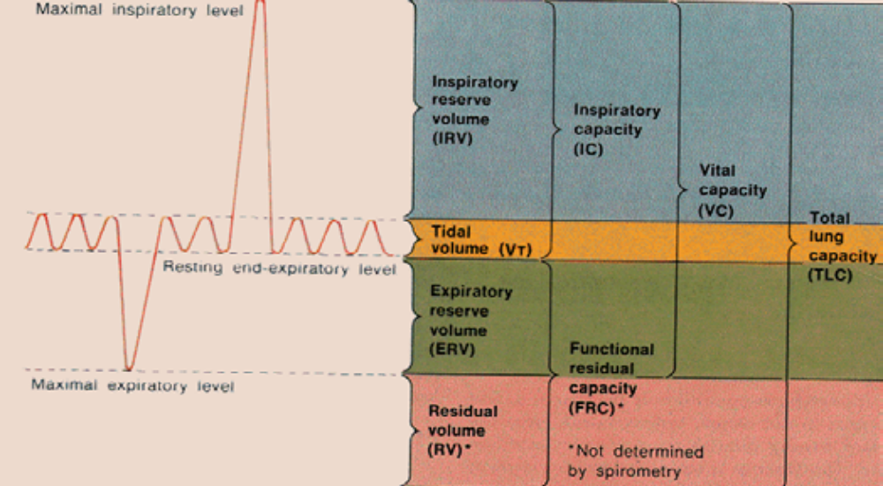

Spirometry:
Measures the lung volume change during forced breathing maneuvers:
􀂉 Forced vital capacity (FVC)
􀂉 Forced expiratory volume in the first second (FEV-1) 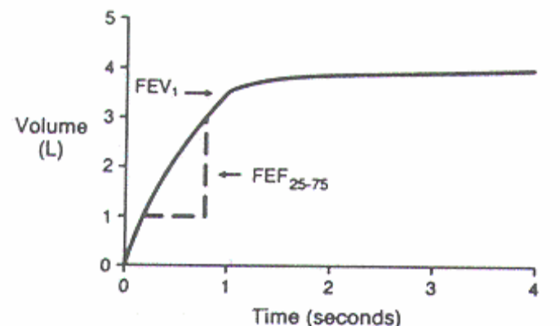

Spirometry | Obstruction | Restriction
FEV-1 | Decreased (--) | Decreased (-)
FVC | Decreased (-) | Decreased (-)
FEV-1/FVC | Decreased (definition) | Normal &  Increased

􀂙 Obstructive Lung Diseases:
􀂉 Emphysema & Chronic Bronchitis
􀂉 Cystic Fibrosis
􀂉 Asthma
􀂉 Bronchiectasis
􀂉 Some Interstitial Lung Disease: (combined)

􀂙 Restrictive Lung Diseases:

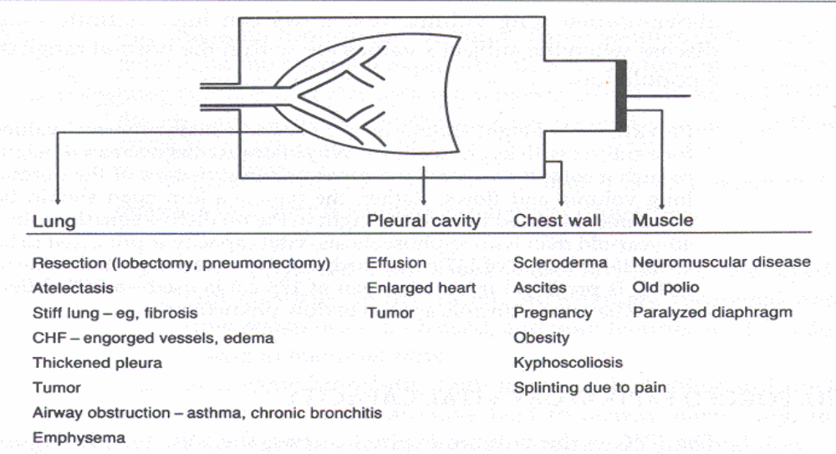

Pre and Post Bronchodilator Spirometry:

􀂉 Goal: to evaluate the reversibility of the airway obstruction.

􀂉 Technique : repeat the spirometry after the treatment with bronchodilator.

􀂉 Criteria: required two criteria at the same time:

200 ml and 12% (both) change in either FEV-1 or FVC

􀂉 Patient with Reversible Airway Obstruction responds to treatment with:

• Bronchodilator (short & long acting)

• Steroid inhaler

Lung Volumes:
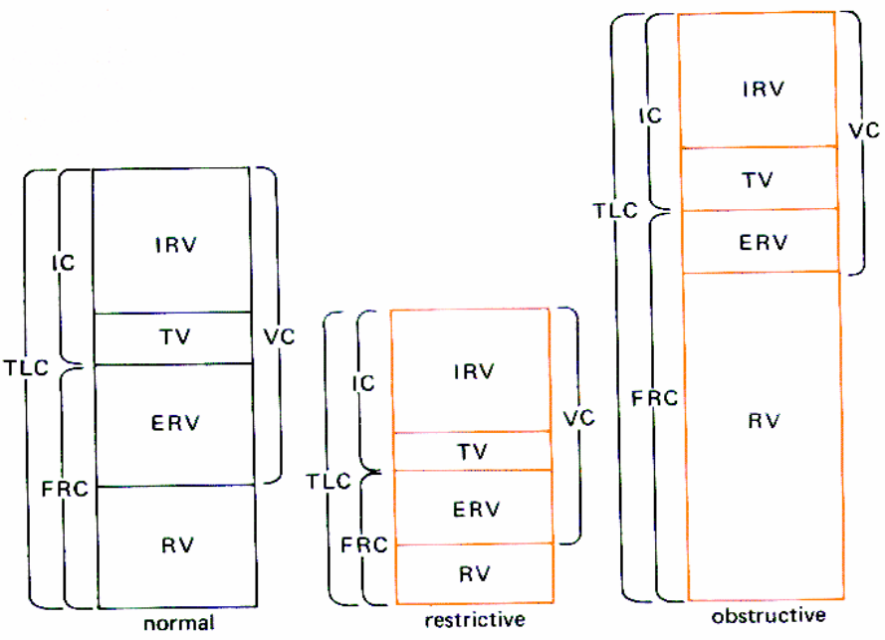

Diffusion Capacity:

Estimates the transfer of oxygen in the alveolar air to the red blood cell.
Factors that influence the diffusion:
1) Area of the alveolar-capillary membrane (A)
2) Thickness of the membrane (T)
3) Driving pressure
4) Hemoglobin

A-Decreased:
1) Decrease the area of the diffusion:
Lung/lobar resection, bronchial obstruction, and IPF.
2) Increase the thickness of the alveolar-capillary membrane: IPF, CHF, pulmonary vascular diseases

3) Decrease the driving pressure: smoking, CO exposure
4) Hemoglobin: Anemia, Hemoglobinopathy.
B- Increased: 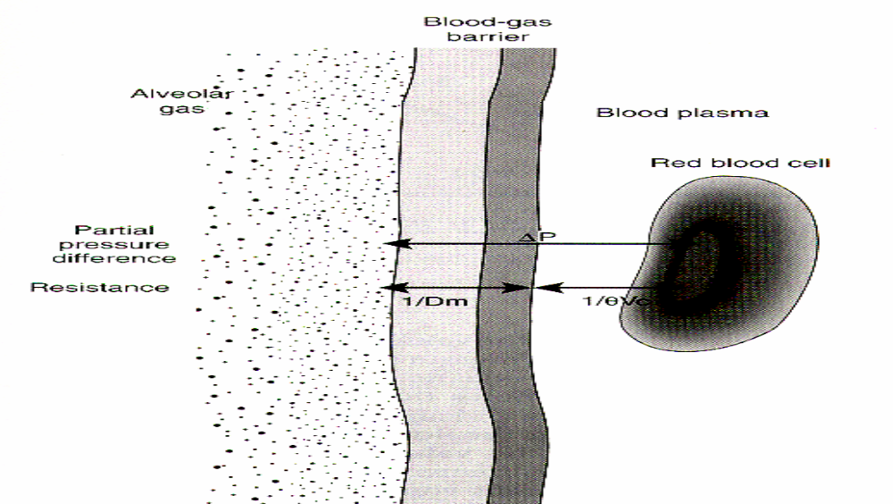
• Pulmonary hemorrhage
• Polycythemia
• Early CHF
• Asthma
• Exercise
• Obesity
• Left to right shunt

Technique:
CO to measure the diffusion capacity (DLCO)

Arterial Blood Gas:
􀂉 Oxygenation (PO2 and FiO2) & Ventilation (PCO2 and PH)
􀂉 Acid – Base balance (PCO2, HCO2, and PH)

Abnormal Pulmonary Function Patterns:
1. Obstructive
2. Restrictive
3. Neuromuscular weakness
4. Pulmonary Vascular
5. Poor Effort

