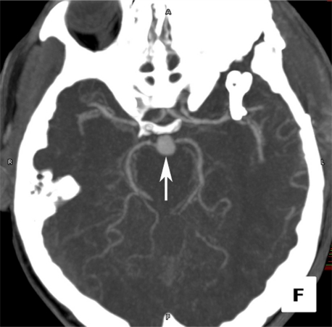
Basilar tip artery aneurysm. Computed tomography angiogram in the axial projection demonstrates a focal basilar tip artery aneurysm (arrow).

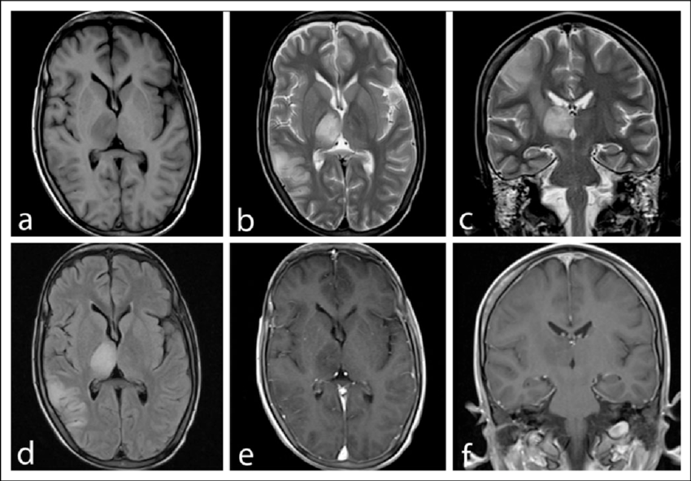
Magnetic-resonance-imaging-MRI-brain-of-the-patient-Note-a-T1-Weighted-axial
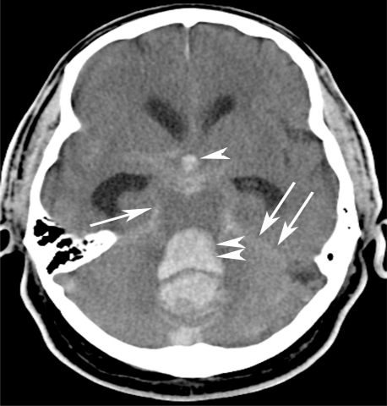
Massive subarachnoid and intraventricular hemorrhage

