Imaging of spinal lesions
The spine:
The bony axial spinal skeleton comprises 7 cervical, 12 thoracic and 5 lumbar vertebrae, as well as the sacrum and coccyx.
Although vertebral structure varies between regions, the vertebrae basically comprise a body, pedicles, lamina and a posterior spine. The bony spinal canal is formed by the body (anteriorly), the pedicles (laterally) and the lamina (posteriorly). The canal contains the spinal dura, the spinal cord and, inferiorly, the cauda equina. The vertebral bodies are joined by fibroelastic discs and articulate via facet joints.

The spinal cord
The spinal cord consists of central grey matter (neuron cell bodies( and white matter (axonal tracts), and gives off 8 cervical, 12 thoracic, 5 lumbar and 4 sacral paired spinal roots. Each root is actually formed from a ventral and a dorsal rootlet arising directly from the spinal cord. The dorsal root contains sensory fibres carrying information from the peripheral nervous system, whose cell bodies reside in the dorsal root ganglia, a small bulge on the back of the dorsal rootlet. The ventral root carries motor fibres whose cell bodies are located in the spinal cord grey matter. The spinal cord is enlarged in the lower cervical region and at the thoracolumbar region (conus), and terminates in the adult at about L1–L2 level. Below the level of the conus is the cauda equina, a collection of the peripheral nerves that innervate the lower limbs, bladder, bowels and genitalia. The sympathetic division of the autonomic nervous system emerges from the thoracic and lumbar spinal cord. The parasympathetic division begins in selected cranial nerves and the sacral spinal cord.

IMAGING OF SPINAL LESIONS
Imaging of spinal lesions refers to the use of various medical imaging techniques to visualize and diagnose abnormalities or lesions within the spinal cord or the structures surrounding it. The spinal cord is a crucial part of the central nervous system, and any pathology in this region can have significant implications for a person's health.
Common imaging modalities used for the evaluation of spinal lesions include:
- X-rays: X-rays provide a basic view of the bones in the spine and can help identify fractures, deformities, or dislocations. However, they are limited in their ability to visualize soft tissues.
- Computed Tomography (CT): CT scans provide detailed cross-sectional images of the spine, offering a clearer view of bony structures. CT is particularly useful in assessing fractures, bone tumors, and spinal stenosis.
- Magnetic Resonance Imaging (MRI): MRI is a powerful imaging tool for visualizing both bone and soft tissues in the spine. It is particularly effective in detecting spinal cord injuries, disc herniations, tumors, and infections. The detailed images produced by MRI help in accurate diagnosis and treatment planning.
- Myelography: Myelography involves injecting a contrast dye into the spinal canal, followed by X-rays or CT scans. This technique helps visualize the spinal cord and nerve roots and is often used when an MRI is contraindicated or not feasible.
- Ultrasound: While less commonly used for spinal imaging, ultrasound may be employed in certain situations, such as assessing spinal cord abnormalities in infants.
- Nuclear Medicine Imaging: Techniques such as single-photon emission computed tomography (SPECT) or positron emission tomography (PET) can be used to evaluate spinal lesions, particularly those related to tumors and infections.

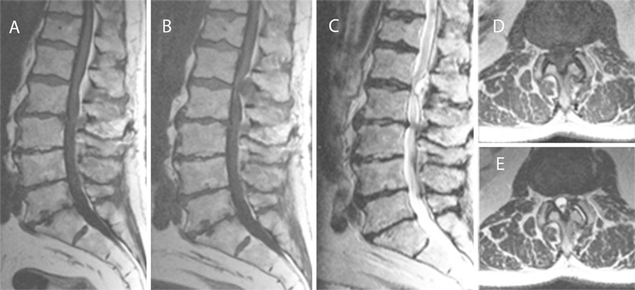

MRI images of the lumbar spine. a Sagittal T1-weighted images from December 2010 demonstrating degenerative discs and osteoarthritis deformities at all lumbar levels. Small retrolisthesis of the second lumbar vertebra combined with severe stenosis of the spinal canal at the L2-L3 level. Less severe stenosis at the L3-L4 and L4-L5 levels. At the L1-L2 level, no extradural mass is demonstrated. However , there is slight bulging of the posterior extradural fat tissue without compression on the conus at the L1-L2 segment.

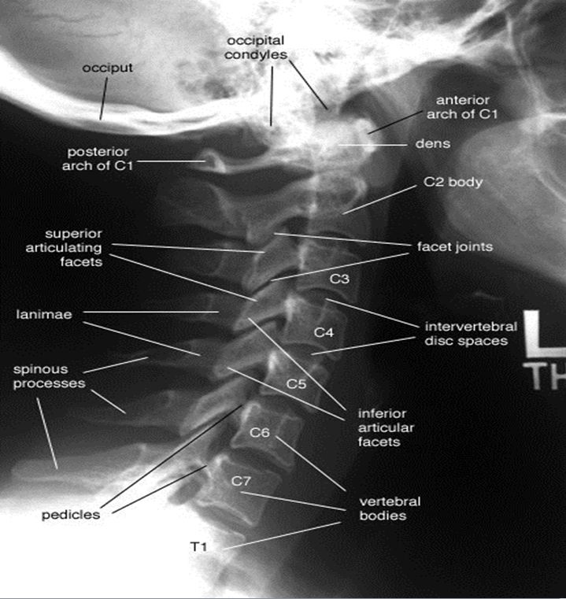

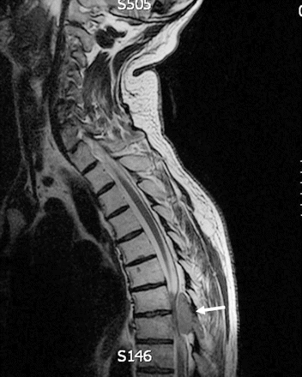

Metastatic spinal cord compression

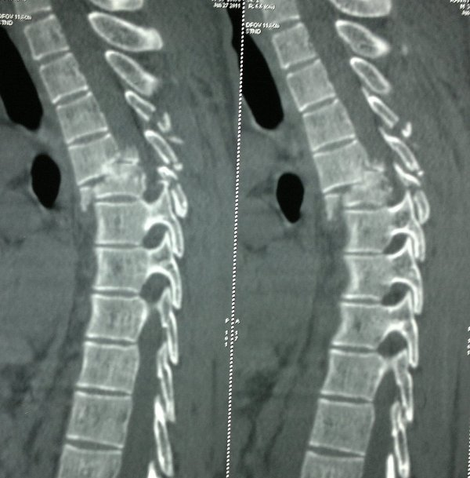

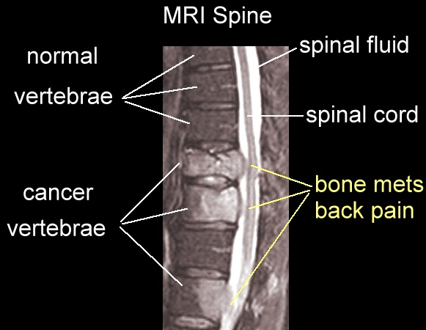

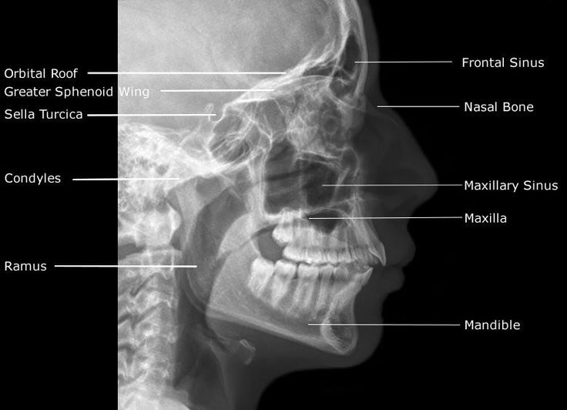

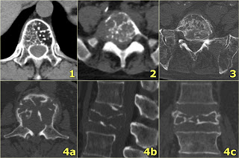

1.Hemangioma. 2-Metastasis. 3- Multiple myeloma. 4-Plasmocytoma: vertebra plana. This 'Mini Brain' appearance of plasmacytoma in the spine is sufficiently pathognomonic to obviate biopsy .

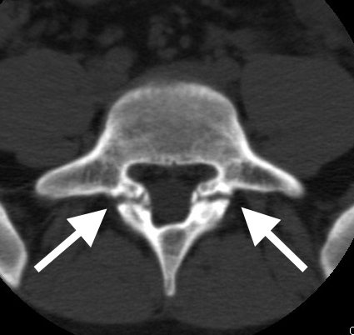

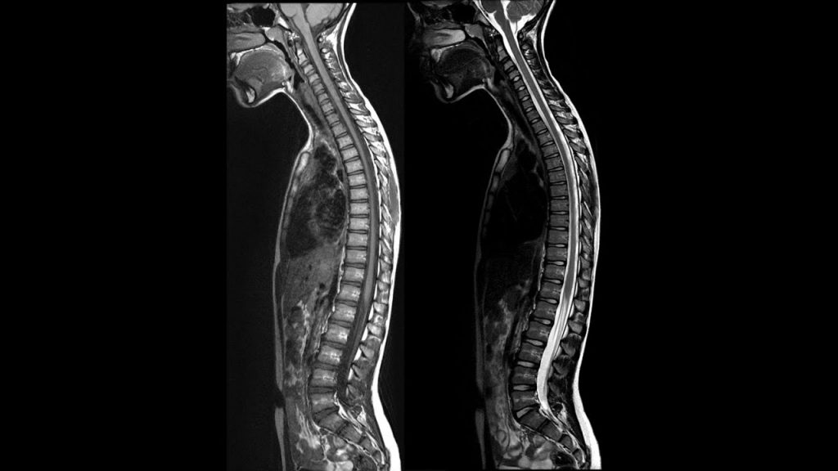
How to tell the difference between MRI and CT scan?

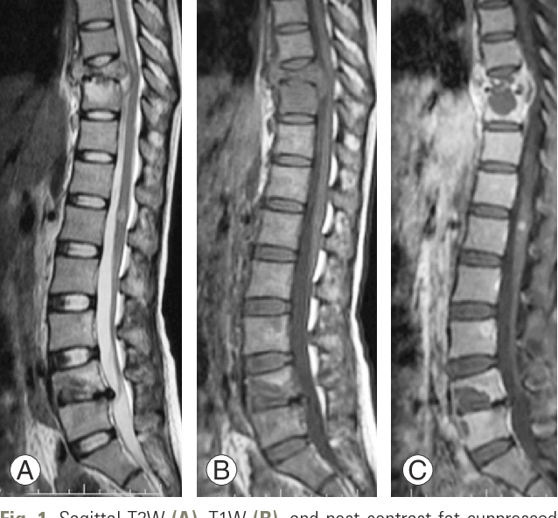

Sagittal T2W (A), T1W (B), and post-contrast fat-suppressed T1W (C) sequences reveal noncontiguous multiple-level spinal tuberculosis involvement at T9–T10 and L4–L5 levels.

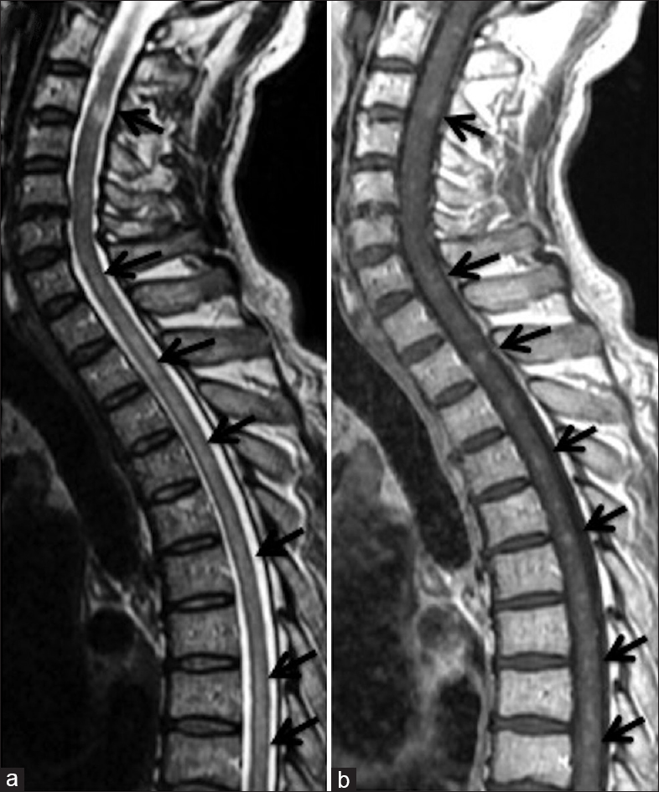

- Cervical and thoracic spinal cord T2-weighted MRI revealed high-intensity lesions extending continuously from the medulla to the conus; and, (b) scattered punctate gadolinium enhancement is seen within this region

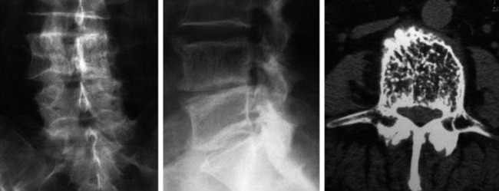
L4 vertebral body hemangioma with coarse vertical trabeculae. Anteroposterior view (left), lateral view (middle), and CT (right).
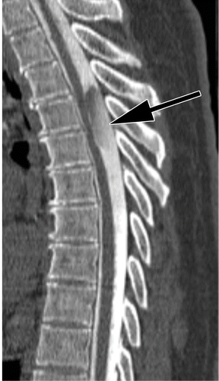
Intradural extra medullary arachnoid cyst in a 56-year-old woman with prior lumbar spine fusion who presented with chronic lower extremity sensory changes and back pain.

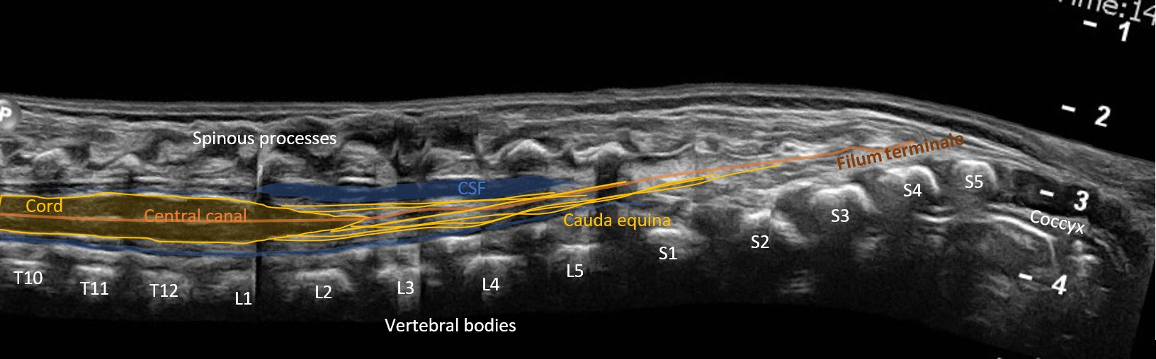

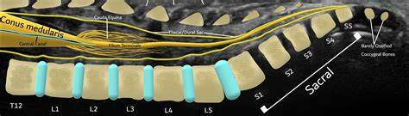
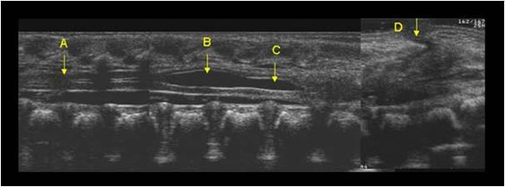
Neonatal spine hydromyelia, tethered spinal cord and meningocele

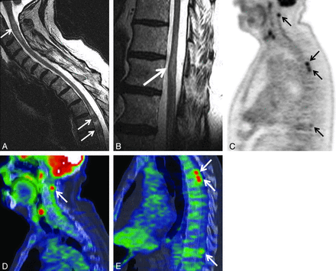

Patient with multiple ISCMs, all visible on PET. A 73-year-old man with non–small cell lung cancer underwent PET 5 days before MR imaging. Precontrast sagittal T2WI of the cervicothoracic (A) and lower thoracic (B) regions; C, sagittal entire spine PET only image; sagittal cervicothoracic (D) and thoracic (E) region PET/CT fused images.

