Understanding Stomach Diseases: A Comprehensive Exploration of Gastric Masses and Ulcers

Introduction:

The stomach, a vital organ in the digestive system, plays a crucial role in breaking down food and facilitating nutrient absorption. However, various factors can lead to the development of diseases that impact its normal functioning. In this lecture, we will explore the anatomy of the stomach, delve into the causes and symptoms of gastric masses and ulcers, and discuss available treatment options.

I. Anatomy of the Stomach:

The stomach is a muscular organ located in the upper abdomen, between the esophagus and the small intestine. It consists of several layers, including the mucosa, submucosa, muscularis externa, and serosa. The mucosa contains gastric glands that secrete gastric juices, essential for digestion. Understanding the normal structure of the stomach is crucial for comprehending the impact of diseases on its functionality.

II. Gastric Masses:

A. Definition and Types:

Gastric masses refer to abnormal growths or lumps in the stomach that can be benign or malignant. These masses can arise from various tissues, including the lining of the stomach (mucosa), the muscular layers, or other adjacent structures.

Benign Gastric Masses:

a. Gastrointestinal Stromal Tumors (GISTs): These tumors originate from the interstitial cells of Cajal (ICCs help regulate motility, secretion, and other functions in the gastrointestinal tract ) and are often benign. However, they can become malignant in some cases.

b. Leiomyomas: Smooth muscle tumors that are typically benign.

Malignant Gastric Masses:

a. Gastric Adenocarcinoma: The most common type of stomach cancer, arising from the glandular cells in the stomach lining.

b. Lymphoma: Non-Hodgkin lymphoma can develop in the stomach and affect the lymphatic tissue.

B. Causes and Risk Factors:

Helicobacter pylori (H. pylori) infection: A bacterial infection associated with an increased risk of gastric cancer and ulcer development.

Genetics: Family history of stomach cancer can contribute to an individual's susceptibility.

Diet: High intake of smoked, salted, or pickled foods may elevate the risk.

Smoking and alcohol consumption: Lifestyle factors that can contribute to the development of gastric masses.

C. Symptoms and Diagnosis:

Early stages may be asymptomatic.

Symptoms may include abdominal pain, unexplained weight loss, nausea, and changes in bowel habits.

Diagnosis involves endoscopic procedures, imaging studies (CT, MRI), and biopsy for pathological confirmation.

III. Gastric Ulcers:

A. Definition and Types:

Gastric ulcers are open sores that develop on the inner lining of the stomach. They can be classified into two main types: gastric ulcers and duodenal ulcers.

Gastric Ulcers: Located in the stomach lining.

Duodenal Ulcers: Found in the upper part of the small intestine (duodenum).

B. Causes and Risk Factors:

H. pylori infection: Major contributor to ulcer formation.

Nonsteroidal anti-inflammatory drugs (NSAIDs): Prolonged use can irritate the stomach lining.

Smoking and alcohol consumption: Lifestyle factors influencing ulcer development.

Stress: While not a direct cause, stress can exacerbate ulcer symptoms.

C. Symptoms and Diagnosis:

Burning stomach pain is a common symptom, especially when the stomach is empty.

Nausea, vomiting, bloating, and unintentional weight loss may occur.

Diagnosis involves endoscopy, blood tests, and breath tests for H. pylori.

IV. Treatment Options:

A. Gastric Masses:

Surgical removal is often the primary treatment for malignant masses.

Chemotherapy and radiation therapy may be employed in advanced cases.
B. Gastric Ulcers:

Antibiotics to treat H. pylori infection.

Proton pump inhibitors (PPIs) and histamine-2 blockers to reduce stomach acid.

Lifestyle modifications, including dietary changes and stress management.

Conclusion:

In conclusion, understanding the complexities of stomach diseases, particularly gastric masses and ulcers, is essential for early detection and effective management. Regular medical check-ups, a healthy lifestyle, and prompt attention to symptoms can contribute to the prevention and successful treatment of these conditions.

GASTRIC ADENOCARCINOMA
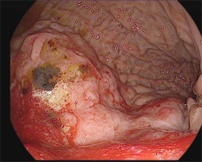
A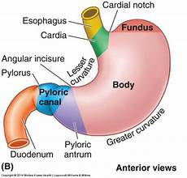

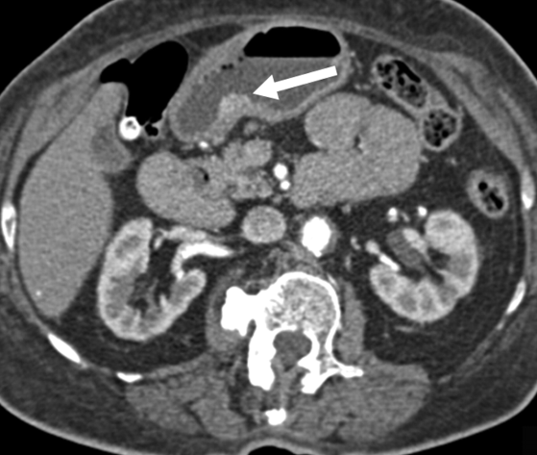
Two patients with gastric polyp. 75-year-old woman who presented with anemia; endoscopy disclosed 3-cm antral mass. Sessile enhancing mass (arrow) arising from mucosa of posterior wall of antrum is seen on axial image from IV contrast-enhanced CT. Pathology revealed 2.1-cm hyperplastic polyp.

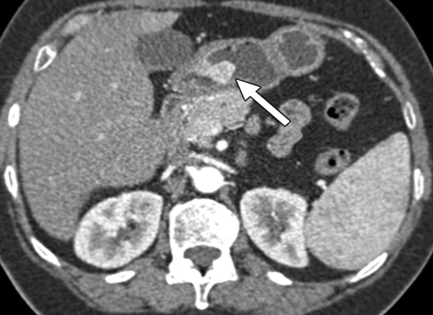
Axial image from IV contrast-enhanced CT shows approximately 2-cm polypoid enhancing lesion (arrow) in antrum of stomach. Differential diagnosis included gastrointestinal stromal tumor, carcinoid or glomus tumor, and less likely gastric carcinoma. Upper endoscopy was conducted, confirming 2-cm antral polyp with superficial ulceration and friable mucosa. At pathology, lesion was shown to be hyperplastic–inflammatory polyp.
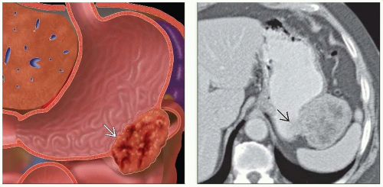
(Left) Anatomic depiction of a gastric stromal tumor shows an exophytic submucosal mass image with internal necrosis. (Right) Axial CECT shows a soft tissue density left upper quadrant mass. The origin of the mass may not be evident, except for a small projection image into the gastric lumen.
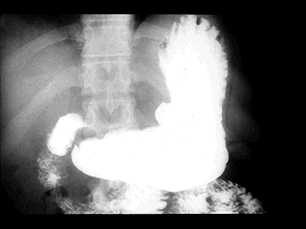
X-RAY: Gastric ulcer. Extraluminal barium collection along the lesser curvature of the body of the stomach

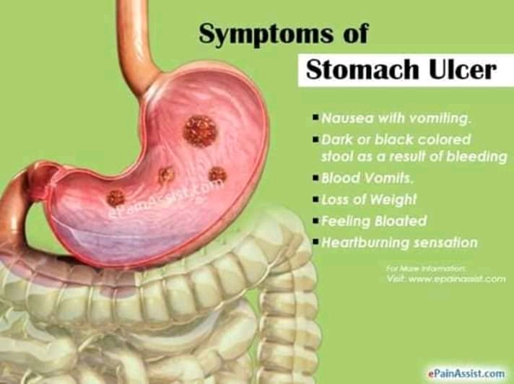

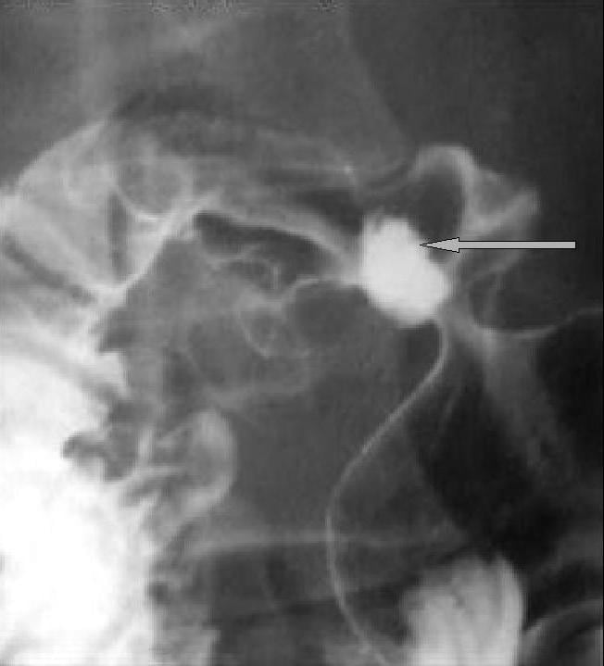
Double-contrast upper gastrointestinal
series. Posterior wall duodenal ulcer.

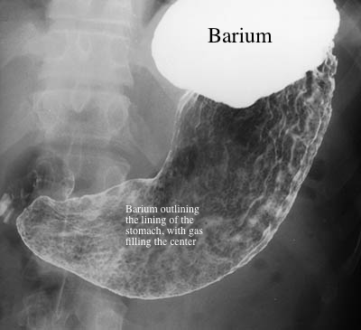
This is a picture of a normal stomach, in a patient who first swallowed a powder that makes gas in the stomach, and then swallowed barium. The barium is white on this image and the gas is dark. The barium is filling the upper part of the stomach, but only coating the lining of the rest of the stomach. This is called a 'double contrast' study, since it uses both Barium (for outlining the stomach) and air (for filling).

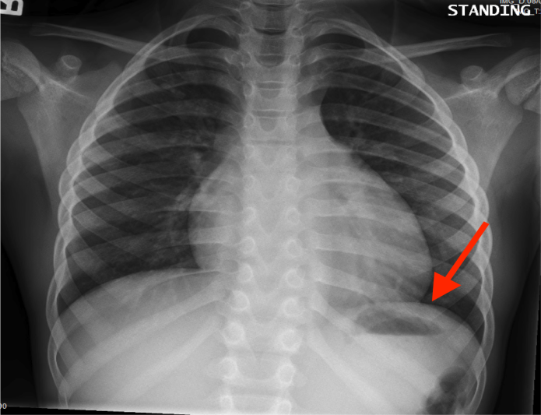
On a frontal chest X-ray the stomach can be seen below the left hemidiaphragm. Take note of the gastric bubble that makes localizing this structure easier.

