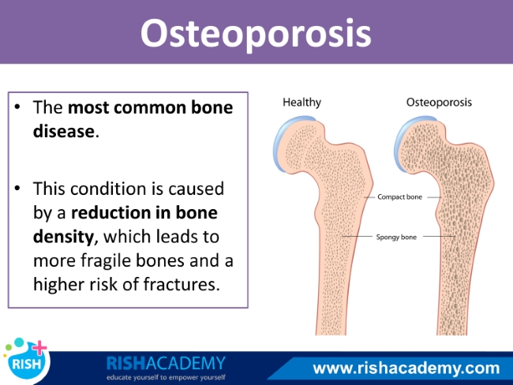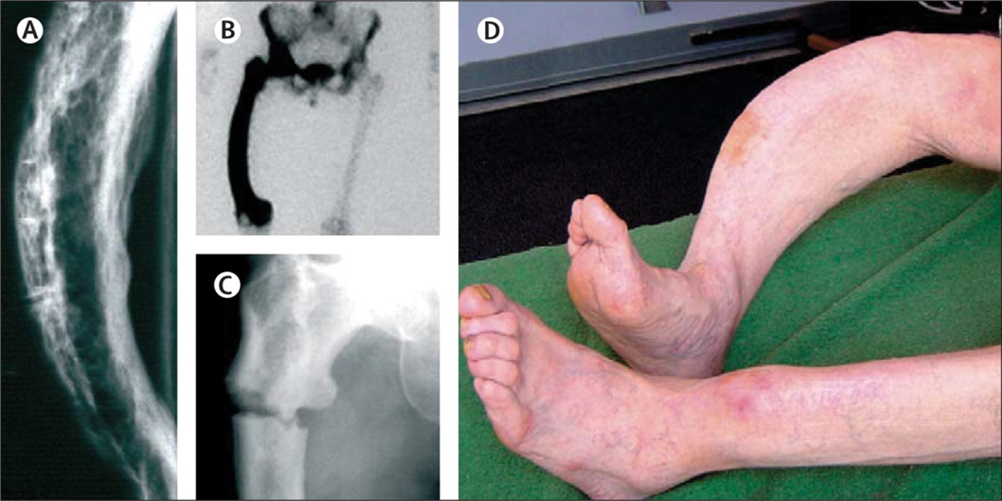.Paget's disease
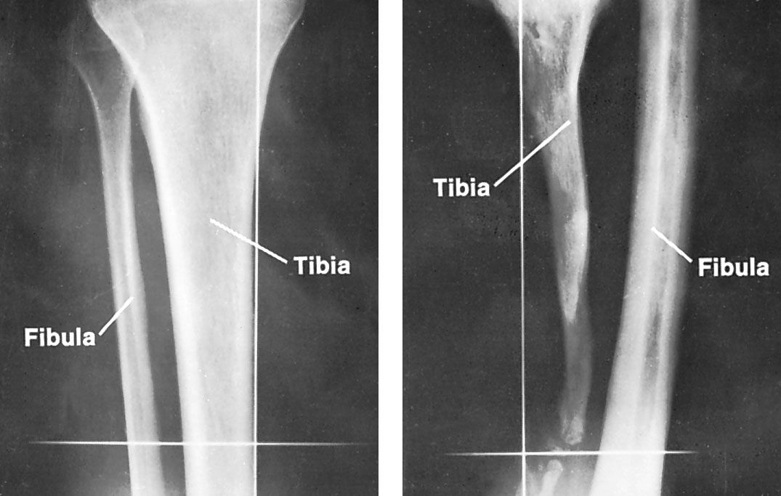
Defect-tibia-thickening-childhood-osteomyelitis-fibula-bones
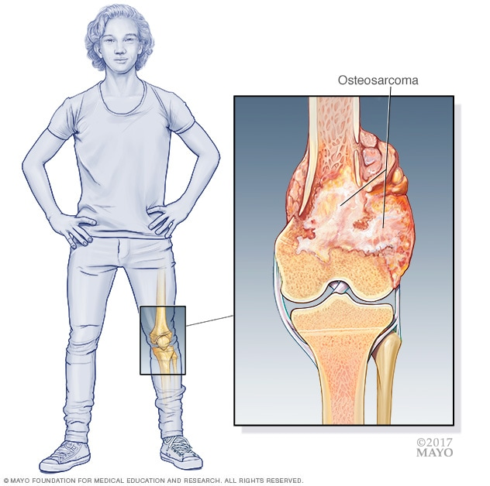
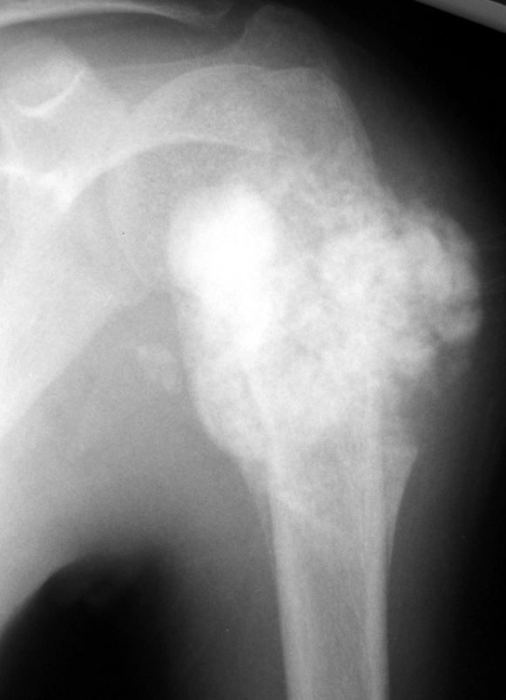
An osteosarcoma in the upper humerus (arm bone). The tumors often appear as cloud-like lesions on X-ray.
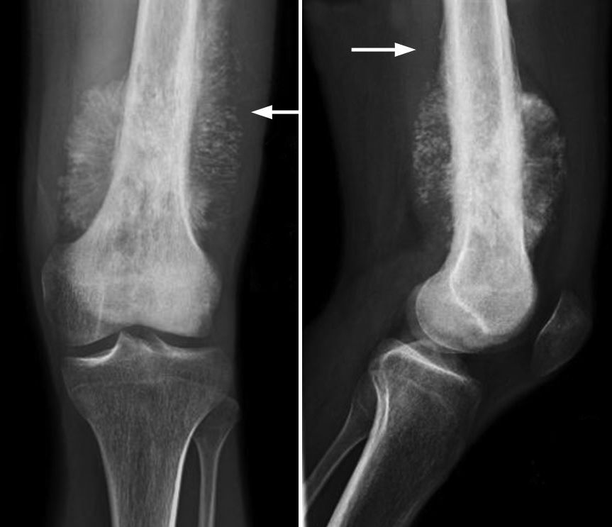
(Left) X-ray shows an osteosarcoma in the femur (thighbone). Note the formation of new bone in a typical "sunburst" pattern. (Right) When viewed from the side, a Codman triangle can also be seen rising from the bone.
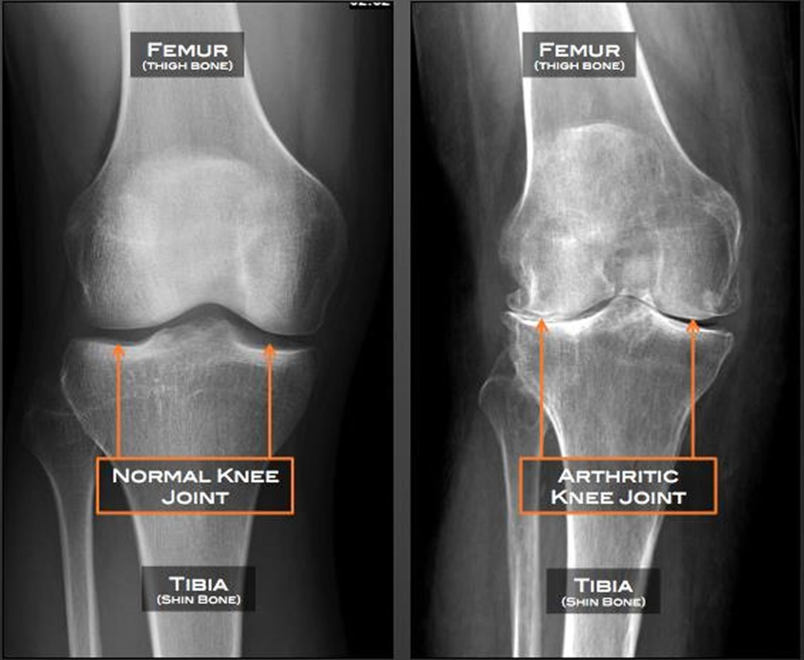
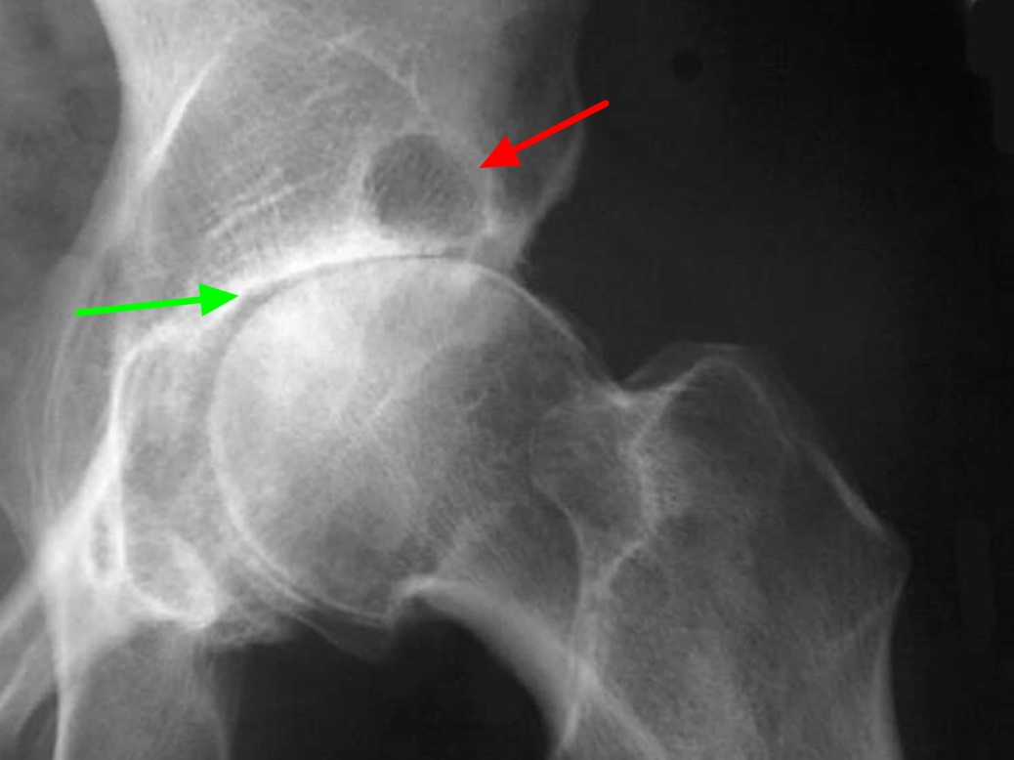
Anteroposterior (AP) radiograph of the hip reveals severe superior migration of the femoral head (which reflects loss of articular cartilage), subchondral sclerosis, prominent osteophytes, and a large Egger cyst in the superior acetabulum. Mild flattening of the superior aspect of the femoral head is present.
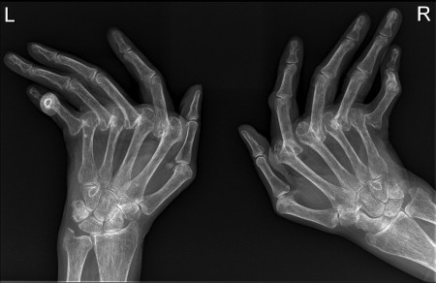
rheumatoid arthritis
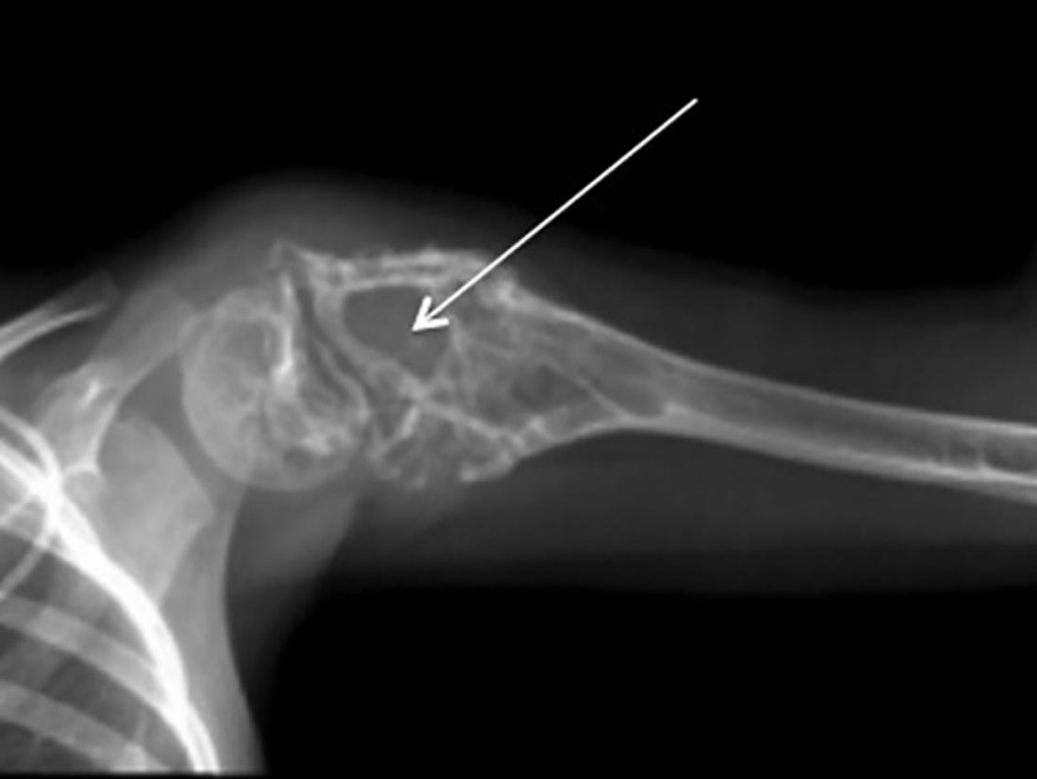
Ewing's sarcoma
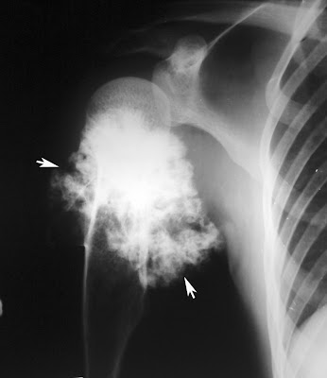
The present radiograph showing development of secondary chondrosarcoma.
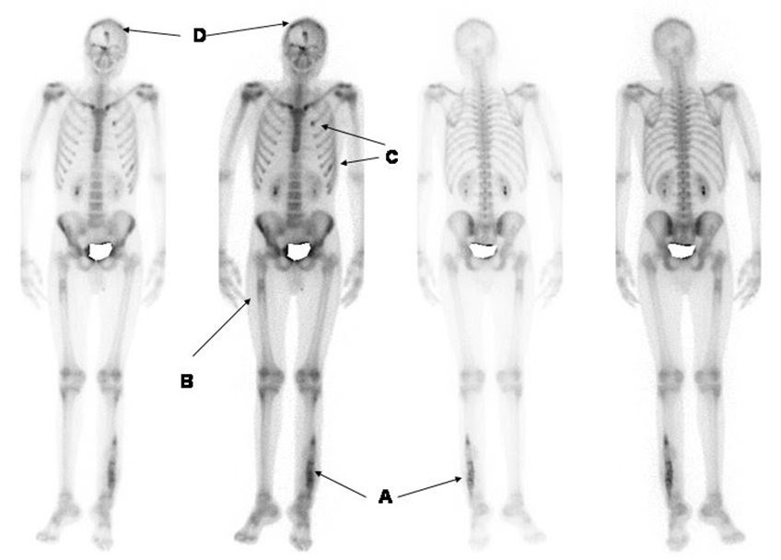 BONE SCAN

