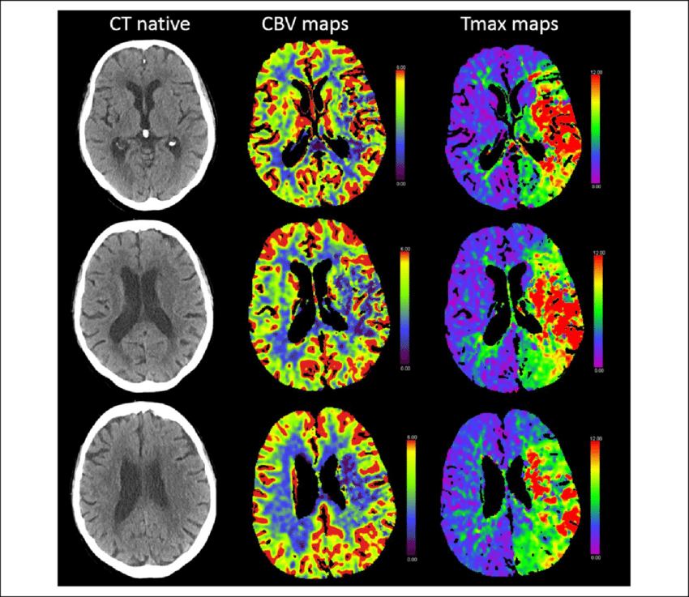
T max CT perfusion maps showing a large area of severe hypoperfusion mainly within the territory of the middle cerebral artery. A greater proportion of the hypoperfused brain tissue showed reduced CBV indices as indicated on the CBV maps. CBV: cerebral blood volume; CT: computed tomography; T max : time to maximum.

