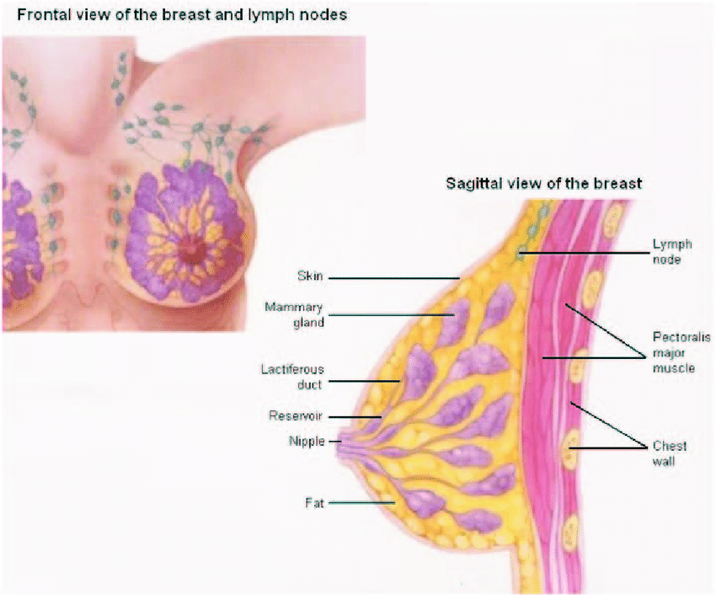
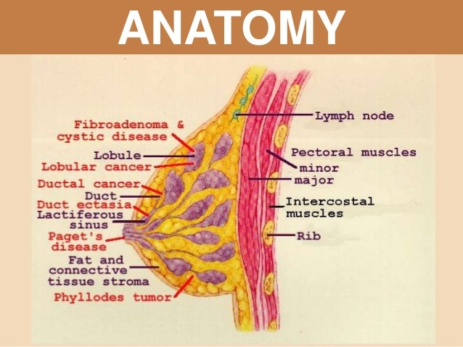
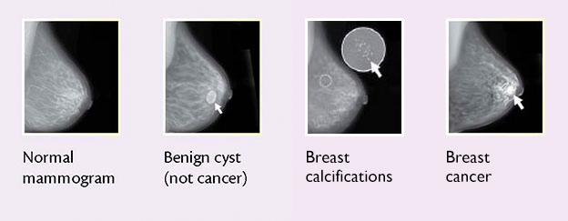

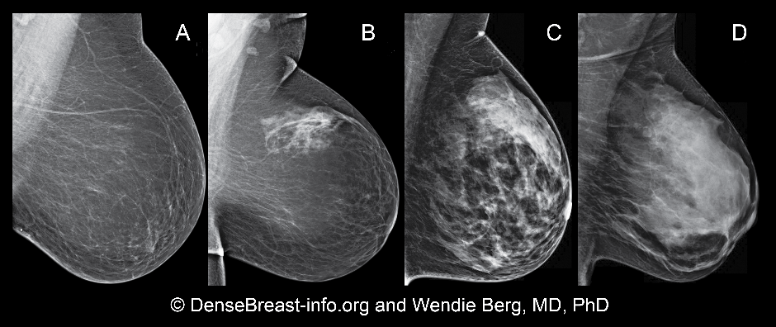
Imaging results of dense breasts can be more difficult for a radiologist to read. But…. not to worry, there’s great news! New mammogram technology called hologic 3d mammography is improving reading outcomes for women with dense breasts. This allows the radiologist to look much more closely at your tissue and makes finding cancerous spots much easier.
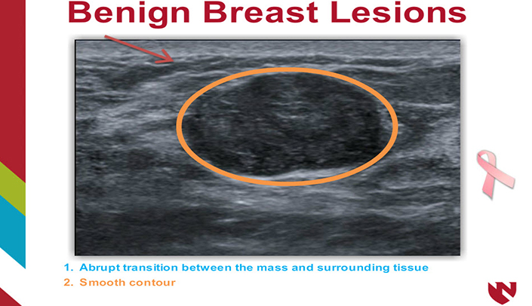
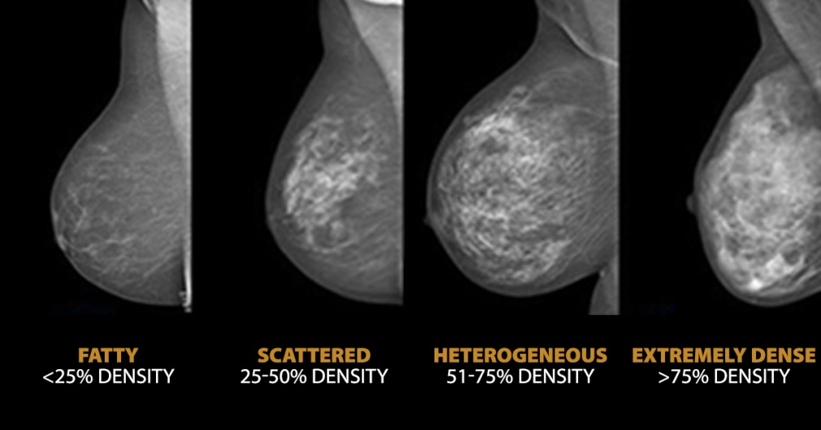
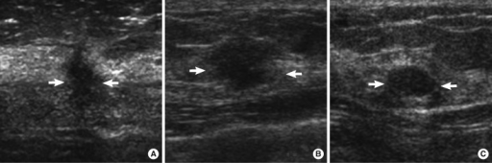
Ultrasonographic findings of malignant and benign breast masses. (A) A mass of invasive ductal carcinoma with irregular shape, not circumscribed margin and hypoechoicity (arrows). (B) A mass of invasive ductal carcinoma with oval shape, not circumscribed margin and hypoechoicity (arrows). (C) A mass, confirmed to be fibroadenoma, showed an oval shape mass, circumscribed margin and hypoechoicity (arrows).
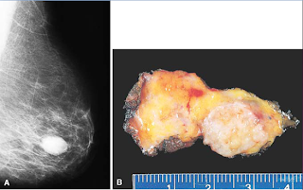
Fibroadenoma. A rubbery, white, well-circumscribed mass is clearly demarcated from the surrounding yellow adipose tissue. The fibroadenoma does not contain adipose tissue and therefore appears denser than the surrounding normal tissue on mammogram.
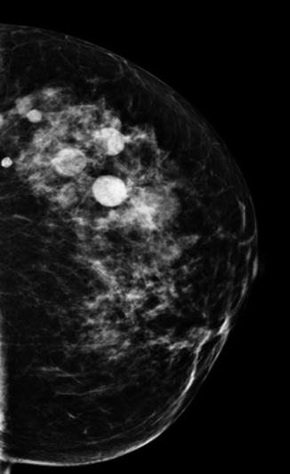
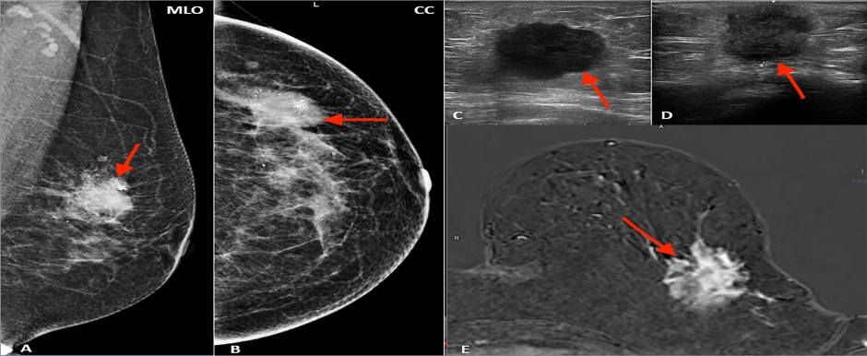
Multimodality presentation of lobular breast cancer; Patient 1 left breast: (A, B) mammography: MLO (A) and CC (B)—not circumscribed, spiculated mass with microcalcifications (red arrow); (C, D) ultrasound—not circumscribed, spiculated, hypoechoic mass (red arrow); (E) MRI T1 post contrast—not circumscribed, spiculated mass with heterogenous contrast enhancement (red arrow).
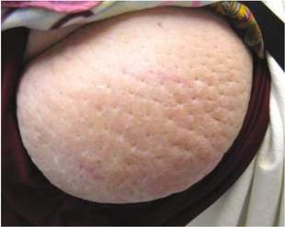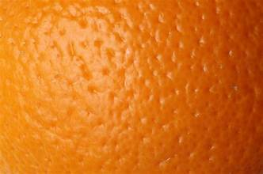
peau d’orange [orange peel]).
